**Tag-and-Probe**

One of the most critical elements of any analysis at CMS is the reliability and accuracy of efficiency measurements. The use of MC simulations will introduce large systematic errors due to inaccuracies of the modelling as well as detector response. One would therefore like to efficiencies of measurements from the data itself, without relying on simulation. The tag-and-probe method offers that. It utilizes a known mass resonance, like $J/ψ, Z$ to select particles of the desired type, and probe the efficiency of a particular selection criterion on those particles.

In general a “tag” is an object that passes a set of very tight selection criteria designed to isolate the required particle type (commonly an electron or muon is used). The fake rate for passing tag selection criteria should be very small (<<1%). Next, a generic set of criteria are defined for the “probes” (loose) by pairing those probes with the tags such that the invariant mass of the combination is consistent with the mass of the resonance. Combinatoric backgrounds may be eliminated through any variety of background subtraction such as fitting, or sideband subtraction. The efficiency itself is measured by counting the number of “probe” particles that pass the desired selection criteria:

$$ϵ=\frac{N_{pass}}{N_{all}}$$

Where $N_{pass}$ is the number of probes passing the selection criteria, and $N_{all}$ is the total number of probes counted using the resonance.

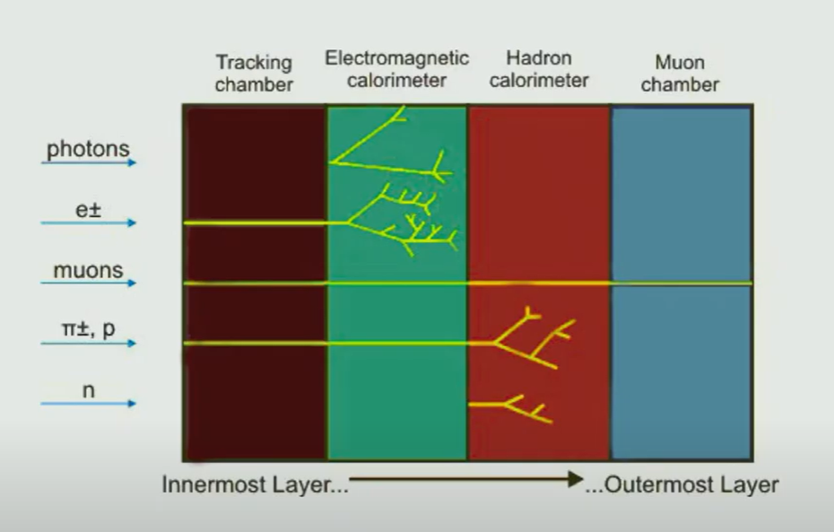

CMS employs a 2level online triggering system that has a rejection factor of up to 10^5. For run 2, the CMS trigger system was upgraded. The new trigger architechture, the Time Multiplexed Trigger (TMT) was introduced which allows the full granularity of the calorimiters to be exploited at the first level of the online trigger. The new trigger system started taking physics data in 2016 following a commissioning period in 2015 and since then has performed extremely well.

The trigger is used to select very small events of interest amongst millions of collisions per second at the LHC. The trigger system in organized in 2 consecutive stages: the L1 and the HLT.

The L1 trigger is implemented using custom hardware and makes decisions based on coarse information from the calorimiters and the muon systems, reducing the rate from 40 MHz to 100 KHz. It has a latency of 3.8 $μ$ s. The software-based HLT partially reconstructs the event, implementing complex selection algorithms on finer granularity information from all sub-detectors in regions deemed interesting by the L1 decision. It runs on a massive computer farm (supercomputer) and reduces the rate further to less than 1.5 kHz.

The CMS electromagnetic calorimeter (ECAL) is a hermetic state of the art system designed for reconstruction of electrons and photons.